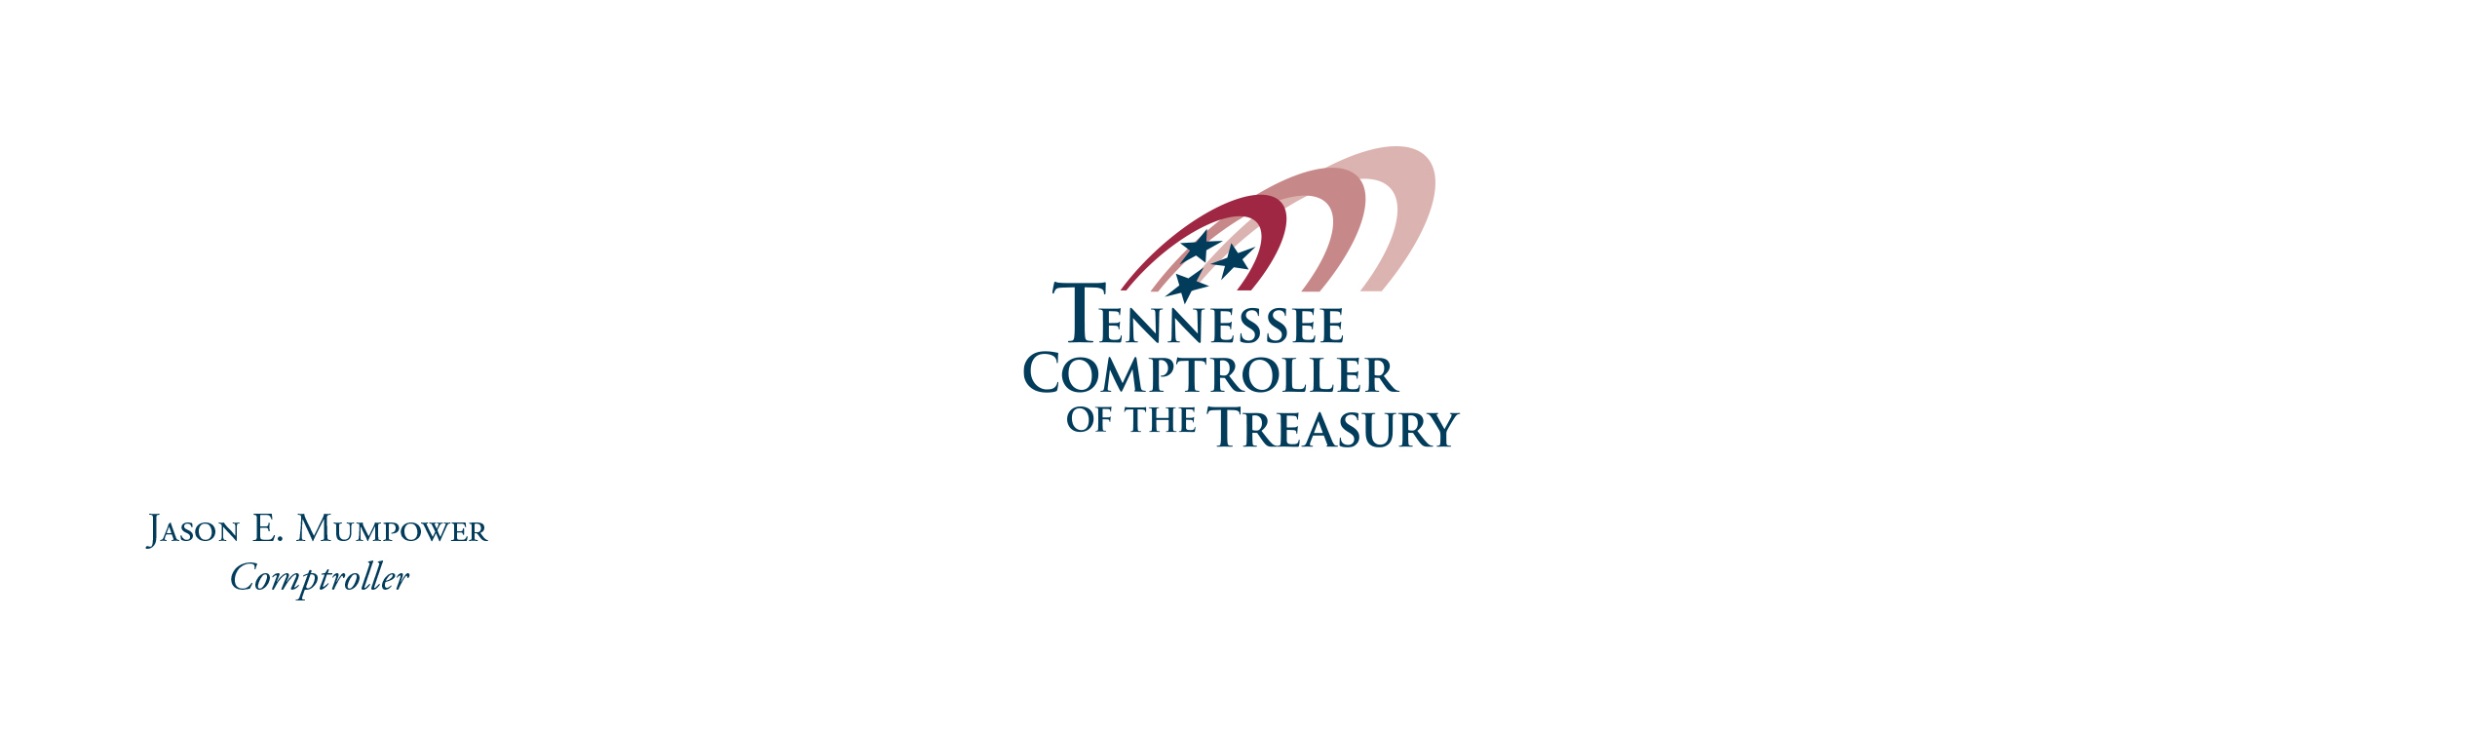

MEETING NOTICE
Tennessee Utility Management Review Board

The Utility Management Review Board will meet on March 11, 2021 at 10:00a.m. (CST) in person and via Microsoft Teams. This meeting is being conducted by electronic means in accordance with Executive Order No. 78, issued February 26, 2021, by Governor Bill Lee.

The meeting will be live streamed and can be viewed by the public through the following link:

Microsoft Teams meeting
Join on your computer or mobile app
Click here to join the meeting
Or call in (audio only)
+1 615-924-8724,,419842266# United States, Nashville
Phone Conference ID: 419 842 266#

The public may attend the meeting in-person at the following location:
IT Training Room
3rd Floor, Cordell Hull Building
425 Rep. John Lewis Way, N.
Nashville, TN 37243

Please note that the meeting will take place in an area of the building that requires special access. Therefore, if a member of the public plans to attend the meeting in-person, please alert the Comptroller’s utilities office by the close of business on Wednesday, March 10, 2021, via email at utilities@cot.tn.gov. Please be aware that a mask will be required while in the building and proper social distancing will be required while in the meeting room.

The agenda, which includes the meeting packet, will be posted on the Comptroller’s website.

